**Testing and Integration**

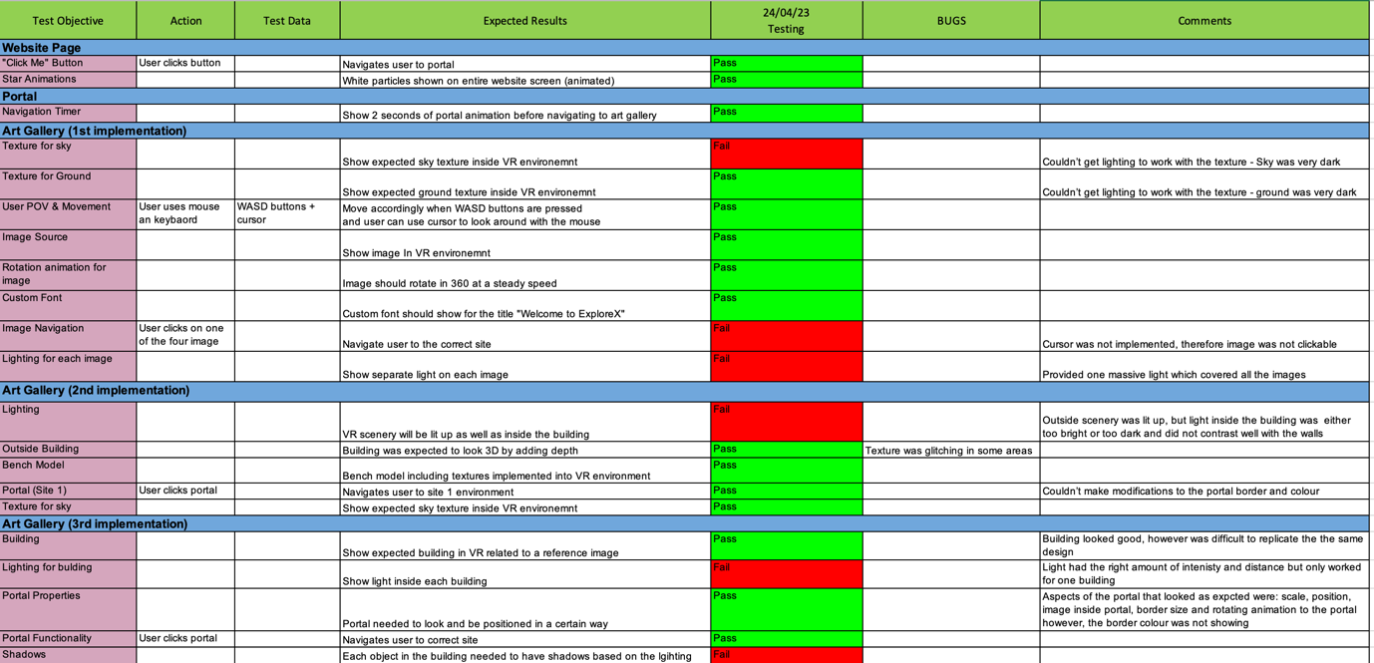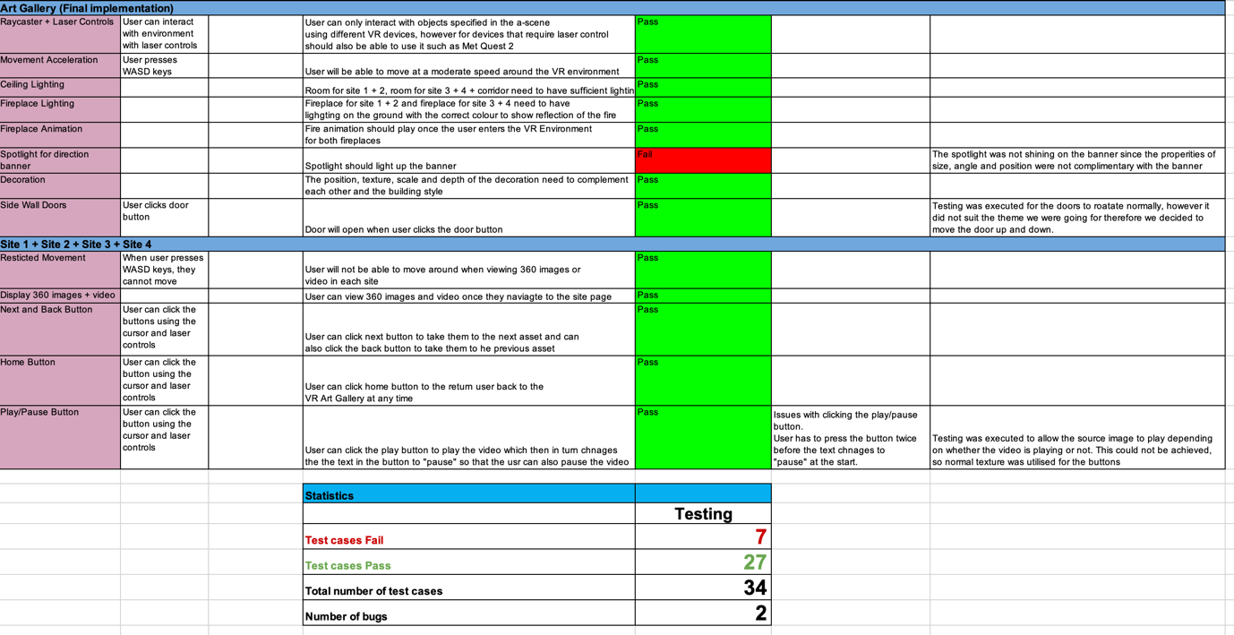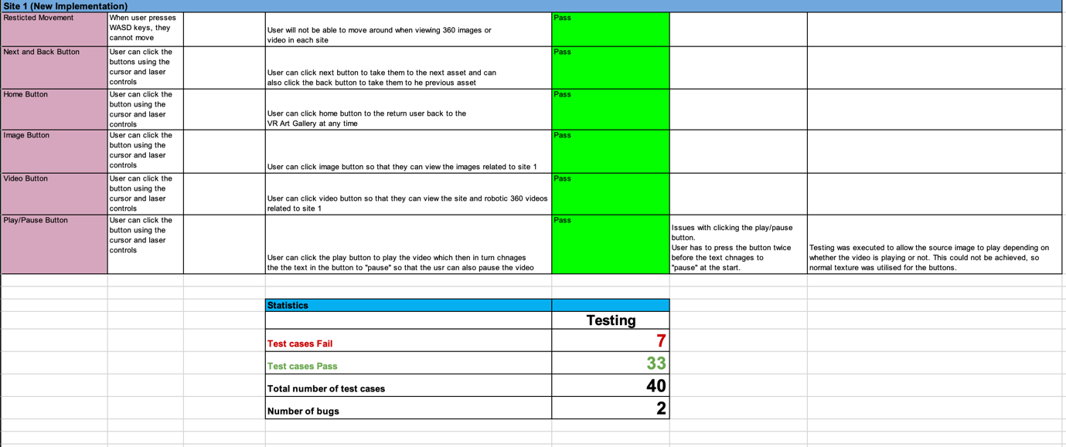

Above is a regression test log which highlights the testing conducted to ensure the VR application meets our standards.

**JMETER TESTING NEEDS TO BE EXPLAINED**

**Maintenance Plan**

We chose GitHub as our repository because of its advanced version control capabilities, ease of collaboration, and interaction with different coding languages, which makes it a dependable platform for our team project.

GitHub: <https://github.com/Mosfeq/ExploreX>